Hashing (SHA256)

Hashing is a technique to convert a given key to unique no using Hash function.

In Blockchain…….

Hashvalue is 64 hexdigits.

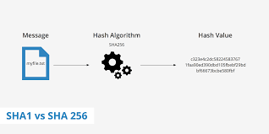

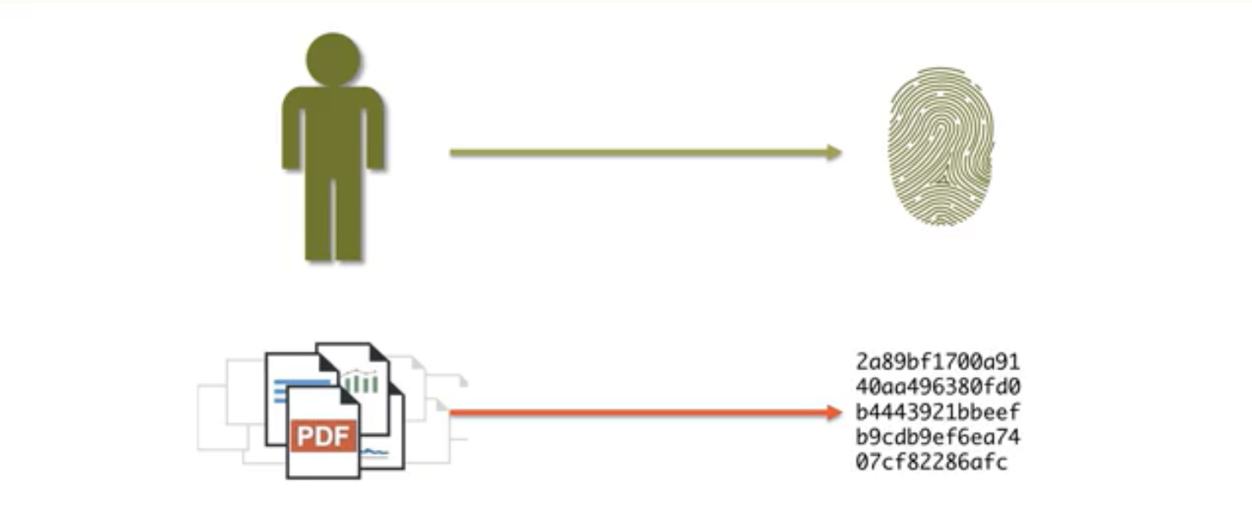

Requuirements of Hash algorithm are:

1.one way

2.deteministic in nature.

3.fast computation

4.Avlanche effect.